Level 19 -> Level 20

The goal of this level is to use the setuid binary in the homedirectory. Password is found in the usual place (/etc/bandit_pass), after we have used the setuid binary.

Use **ls -la** to find out all the files and there permissions, user, etc. The red mark indicates that the file has elevated it’s permissions.

We will execute the setuid binary without any argument so that we can get to know about how to use it. For execution we will use command: **./bandit20-do**

**It says that we should execute this file as another user. Example is also present: ./bandit20-do id**

**Id can be: cat /etc/bandit_pass/bandit20**

So, the command used to get the password is:-

**./bandit20-do cat /etc/bandit_pass/bandit20**

**We got the password…**

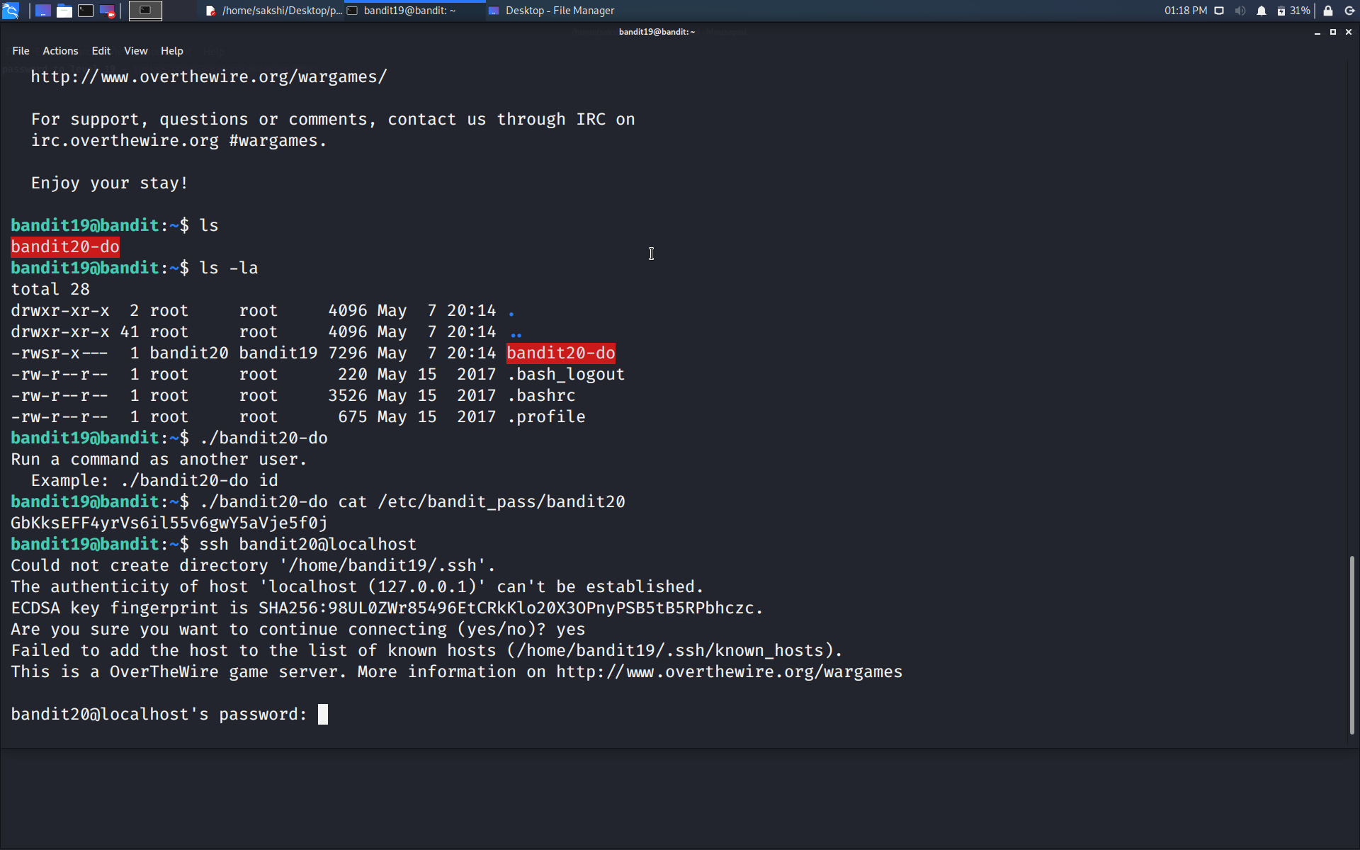

Use the command **ssh bandit20@localhost** to connect to the level 20.

Enter the password and hit enter.

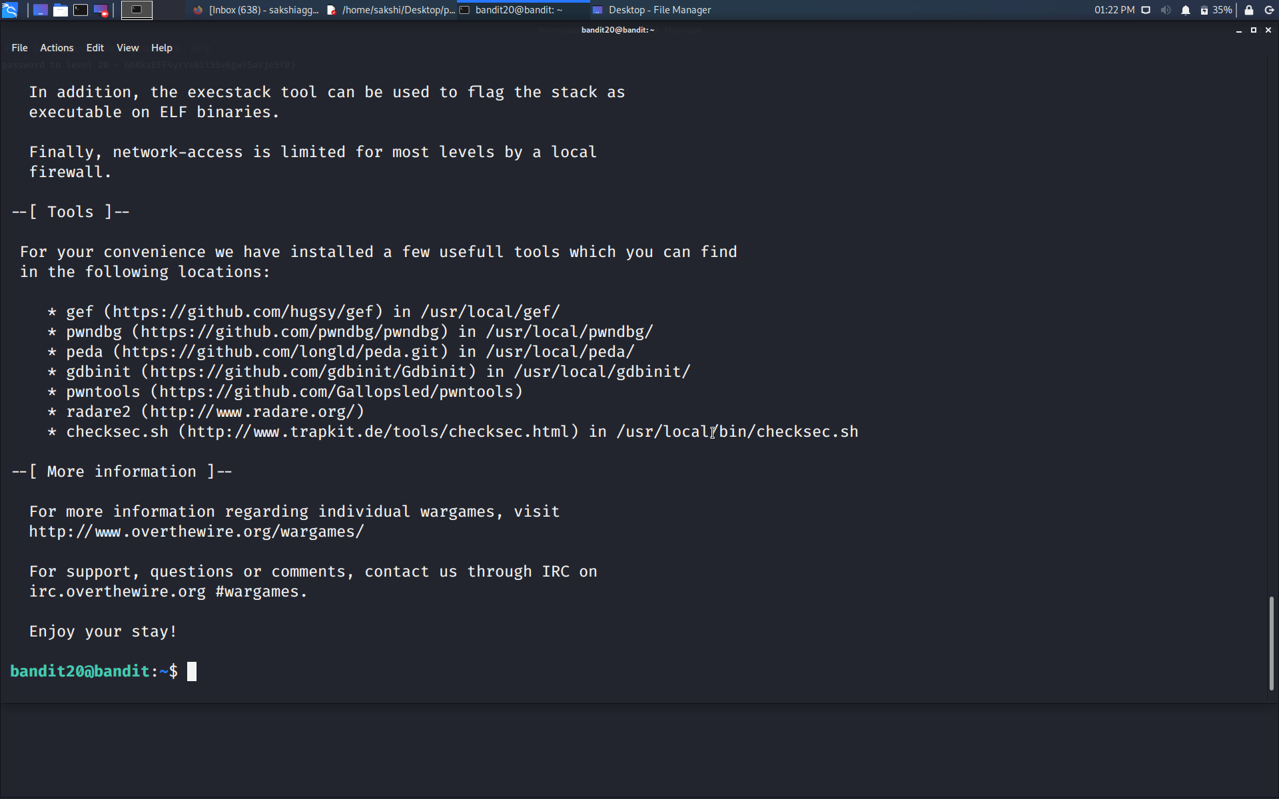

Successfully passed level 20.…